**Karan Arora** **R.L. Institute M: 9416974837**

**Max Time : 1 hr** **Class = 10th Science Test Max Marks : 25**

**Topic: Chemical Reaction & Equations + Life Processes**

1. Multiple choice questions : [ 1 X 5 = 5]

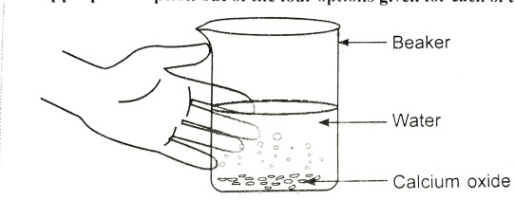

1. Above diagram represent the following reaction : CaO (s) + H2O (l) ‘X’. Identify ‘X’:

|  |  |  |  |
| --- | --- | --- | --- |
| a) CaCO3 | b) CaCl2 | c) Ca(OH)2 | d) CaOCl2 |

1. Identify the sign shows that a product is obtained as a precipitation:

|  |  |  |  |
| --- | --- | --- | --- |
| a) $→$ | b) $↑$ | c) $←$ | d) $↓$ |

1. Look at the figure and table , select the incorrect option:

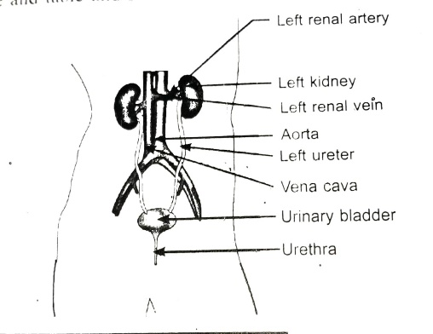

|  |  |
| --- | --- |
| a) Kidney Filter the Blood | b) Urethra Filtering unit of Kidney |
| c) Urinary Bladder Stores urine | d) Ureter Passage of urine |

1. Which of the following correctly represent the labels B , C , D and E respectively :

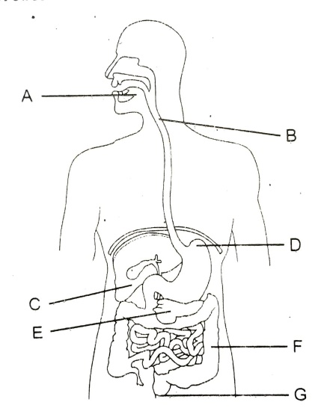

|  |  |
| --- | --- |
| a) Pancreases , Oesophagus , Stomach , Liver | b) Oesophagus , liver , Stomach , Pancreases |
| c) Stomach , Liver , Oesophagus , Pancreases | d) Oesophagus , Pancreases , liver , Stomach |

1. Fe2O3 + 2 Al Al2O3 + 2 Fe. The reaction is an example of ___________.

|  |  |
| --- | --- |
| a) Combination reaction | b) Decomposition reaction |
| c) Displacement reaction | d) Double decomposition reaction |

1. What happens when an aqueous solution of sodium sulphate reacts with an aqueous solution of barium chloride? State the physical conditions of reactants between them will not take place. Write the balanced chemical equation for the reaction and name the type of reaction. [ 2 ]
2. Explain the process of nutrition in Amoeba. [ 2 ]
3. (a) Lack of oxygen in muscles often leads to cramps among cricketers. Explain why? [ 2 ]

(b) White Blood Corpuscles are called ‘Soldiers of the Body’. Why?

1. Identify the substance oxidized and reduced in the following reactions: [ 2 ]

(a) Cu + H2 Cu + H2O (b) MnO2 + 4 HCl MnCl2 + 2 H2O + Cl2

1. Differentiate between arteries and Veins. [ 2 ]
2. The following diagram displays a chemical reaction. Observe carefully and answer the following questions.

[ 3 ]

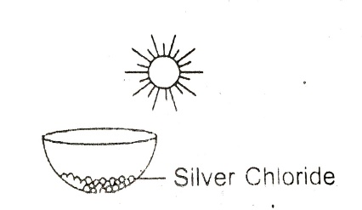

1. Identify the type of chemical reaction that will take place and define it. How will the colour of the salt change?
2. Write the chemical equation of the reaction that takes place.
3. Mention one commercial use of this salt.
4. (a) How is small intestine in human beings designed to maximize absorption of food? [ 3 ]

(b) What are the methods used by plants to get rid of water?

1. Draw a well labelled diagram of Human Heart. [ 4 ]